Phishing Awareness Analyzer - Project Report

Name : Kritika Grover
Project: Cyber Security Project 3 - Phishing Awareness Analysis

Objective
To analyze email or message content and identify phishing attempts by detecting suspicious keywords and links.

Technologies Used
Python 3
Visual Studio Code
Python Standard Library (re)

Project Description
This application analyzes messages for phishing keywords and URLs, displays detected red flags, and warns the user if the message appears suspicious.

Features
- Detect suspicious keywords
- Detect URLs
- Show phishing red flags
- Explain why the message is unsafe

Python code

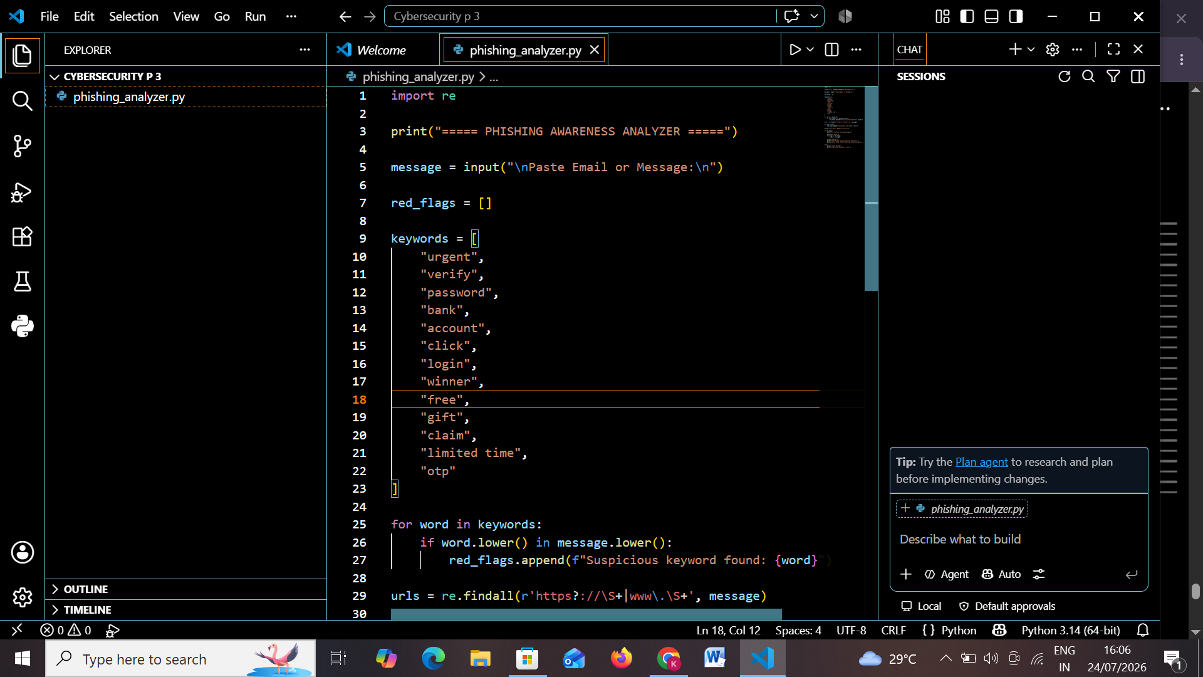
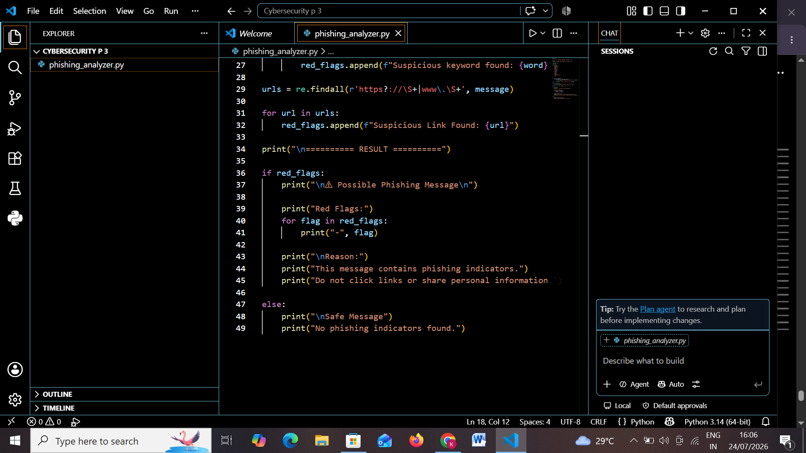

Sample Input
Example - Congratulations! You have won a FREE iPhone. Click here: https://claim-your-prize-now.com Verify your account and password.

Expected Output
Possible Phishing Message with detected keywords, URL, and safety warning.
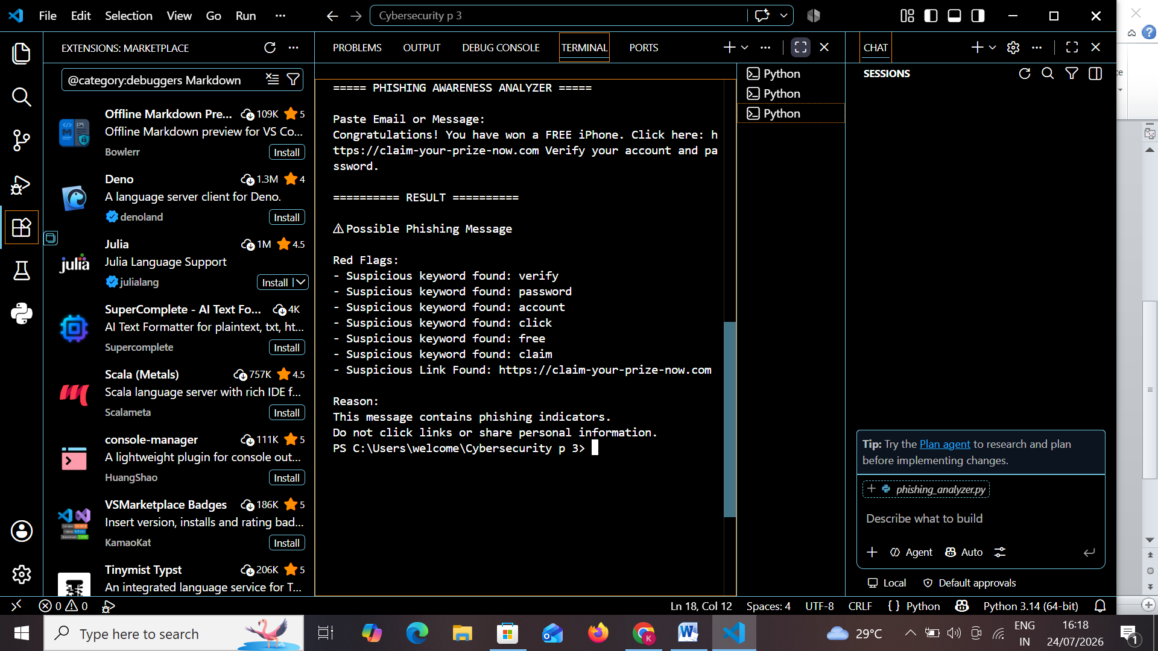

Conclusion
This project improves phishing awareness by helping users identify suspicious messages before interacting with them.

